*هذا العمل هو مجرد اجتهاد من طالب فقط وقد يحتمل الصحة والخطأ. وهو شامل لكل اختبارات الفاينل السابقة.

**Mid1 Questions:**

**Question 1. What is a web server? Give 2 examples and explain their advantages and disadvantages? (10 points)**

* Web servers are the computers that actually run websites.
* Examples:

a) Internet Information Server/Services (IIS).

b) Apache.

* (IIS) Advantages:
* It is has a GUI interface, which makes the installation a bit easier.
* Works well with other Microsoft applications.
* Performance Monitor feature is very useful.
* Good Tech Support.
* (IIS) Disadvantages:
  + It only works with the Windows OS.
  + It is not a terribly flexible web server, due to Microsoft constraints.
  + Source code is proprietary.
* Apache advantages:
* Industry standard for most web servers.
* Open source.
* Allows remote administration.
* Multi-platform.
* The software is free.
* Apache disadvantages:
* Console mode installation.
* No real tech support, except for message boards and third party vendors.
* Apache is not regularly updated.
* Requires more technical knowledge to install and configure.

**Question 2. What is a Virtual Host? And what are the advantages of using it ? Explain its methods in details? (10 points)**

* Virtual hosting is a method that servers such as web servers use to host more than one domain name on the same computer, sometimes on the same IP address.
* Its main advantage is: cost-effectiveness because you won't have to pay for a dedicated server to host just your website.
* Virtual web hosting is a good solution for small- to medium-sized websites that aren't constantly being visited or that have reasonable bandwidth needs.
* Two methods:
  + Name based
  + IP based
* Virtual host name-base:
* The browser sends the URL to the server.
* The server can use this information to determine which web site, as well as page, to show the user.
* For example: www.site1.com and www.site2.com, both resolve to the same IP address.
* For www.site1.com, the server would send the HTML file from the directory /var/www/user/abc/site/, while requests for www.site2.com would make the server serve pages from /var/www/user/xyz/site/.
* Fails when site is accessed through IP.
* Can not work in secure environment.
* Virtual host IP-based:
  + - In IP-based virtual hosting each site points to a unique IP address.
    - The client is not involved in this process.
    - It can serve only a certain maximum number of requests per second depending on:
    - the HTTP request type,
    - whether the content is static or dynamic,
    - whether the content is cached,
    - hardware and software limitations of the OS of the computer on which the web server runs.
    - When a web server is near to or over its limits, it becomes unresponsive.

**Question 3. Write an HTML code to create a webpage that has the following features (30 points):**

1. Title of the webpage "**CSC457 Internet Technology**"
2. Background color is yellow, center alignment, and font size 24pt using ***class attribute and***  ***CSS external file***.
3. Write "This is a red centered paragraph" in the webpage.

Answer:

**CSS file : test1.css**

body{ background-color: yellow}

p.red {font-size: 24pt; color: red}

p.center {text-align: center;}

**Html File :**

<html>

<head>

<title> الانترنتCSC457 Internet Technology </title>

<link rel="stylesheet" type="text/css" href="test1.css" />

</head>

<body>

<p class="red center"> This is a red centered paragraph. </p>

</body>

</html>

**Mid2 Questions:**

**Question 4. Write HTML code using JavaScript popup an alert has " HELLO WORD" Massage when clicking on a button:**

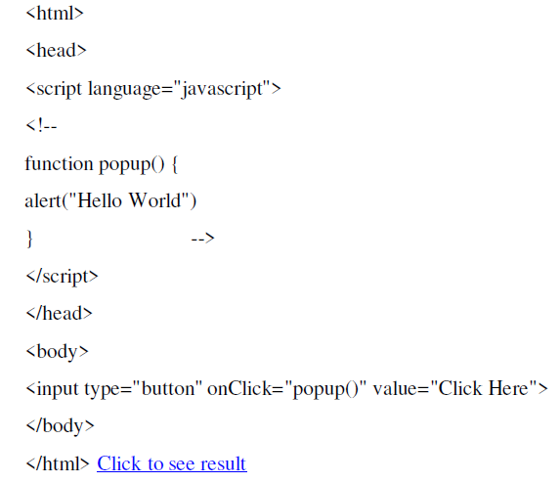

**Question 5. Write a JavaScript to detect the following properties of browser:**

**Browser type , if cookies enabled , the language being used.**

<html>

<body>

<p id="infoBrowser"></p>

<script>

document.getElementById("infoBrowser").innerHTML

="Broswer Type is "+navigator.userAgent

+" Cookie "+navigator.cookieEnabled

+" language: "+navigator.language;

</script>

</body>

</html>

**Question 6. List and explain advantages and disadvantages of the three possibilities of making a web site dynamic ?**

* **Server side processing**: Server is responsible for executing a program (script) and then sends the results in HTML format to client (browser) to interpret.
* **Advantages :**
  + 1. Application logic resides at one place (i.e. server).
    2. Ensures better security.
* Examples: ASP and JSP.
* **Client side processing**: Refers to the processing done at the browser. The browser has two primary parts: the interface (which is the part we see) and the processing software (which is the part that we do not see). The browser interface still has to send messages, but it sends them internally to another part of the overall browser software.
* **Advantages:**

1. Customize interaction with the user
2. Validate user input
3. It reduces the load on the web server.
4. Less information must travel between the server and the Client.
5. Saving time and bandwidth.

* Ex: VBScript and JavaScript.
* **Mix of server side and client side processing**: a normal approach. Client side processing is used for formatting the page and validating the input. Secured info like user id and password should not be done on client side.

**Question 7. What is namespaces in XML? How it could be used ?**

* Namespaces usually take the form of a URL, beginning with a domain name. an optional namespaces label in the form of a directory name and finally version number, which is also optional:

Xmlns= “http://www.mydomain.com/ns/animals/1.1”

* Used to provide a unique name for a document.

**Question 8. What is a web service ? what is the SOAP? Explain the SOAP elements briefly?**

* A service that is platform independent, will work between systems that are distributed and can communicate through firewalls without raising security issues.
* SOAP stands for Simple Object Access Protocol; it is a protocol for accessing web services based on XML.
* **SOAP Envelope Element** it’s the root of SOAP message , defined the XML document as soap message
* **SOAP Header Element** its optional , its contains header information, its contains application-specific information(like payment, authentication)
* **SOAP Body Element** contains the actual SOAP message intended for the ultimate endpoint of the message
* **SOAP Fault Element** holds error, status information for a SOAP message. It is optional.

**Additional Questions:**

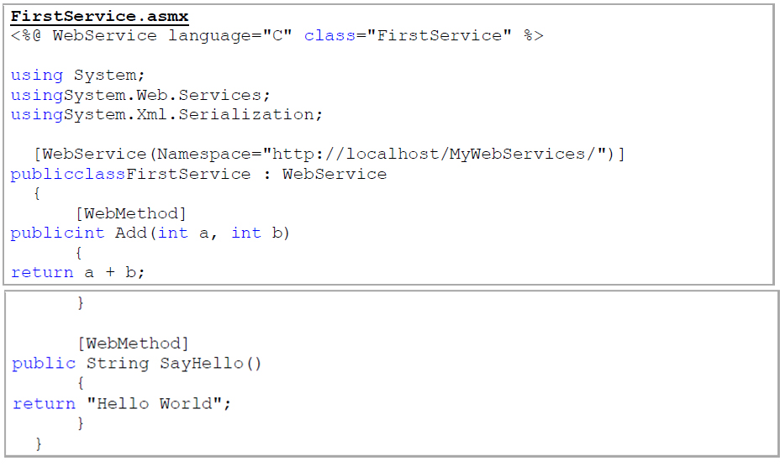**Question 9. Write a .NET webservice to add 2 numbers and return the result. Show the webservice extension file name and the attributes being used. The domain name to host the websirvice is :** [**www.abcd.com**](http://www.abcd.com) **and the directory is mywebservice. (10points)**

**Question 10.** **List the steps needed to access the database from an ASP Page? (10 points)**

The common way to access a database from inside an ASP page is to:

* Create an ADO connection to a database
* Open the database connection
* Create an ADO RecordSet
* Open the RecordSet
* Extract the data you need from the RecordSet
* Close the RecordSet
* Close the connection.

**Question 11. What is an ASP session and why would we need it? How is it created and destroyed?**

**(**Maybe not complete answer)

* ASP session is a state that is used to store and retrieve values of a user.
* ASP's Session Object is only created when we store information into the Session Contents collection.
* The server destroys the Session object when the session expires or is abandoned.
* We need it because web server does not know who you are and what you do.

**Question 12. Write an HTML code using an ASP script to display a dropdown list has three options ( display hello word, redirect to Yahoo.com, and redirect to Google.com) . Show all file names and their extensions. (10 points)**

(Maybe not complete answer)

<html>

<head>

<title>

redirect example html

</title>

</head>

<body>

<form action="http://localhost/05 redirect_example.asp" method="get">

<select name="wheretogo">

<option selected value="hello"> hello message </option>

<option value="Yahoo">Yahoo </option>

<option value="Google">Google </option>

</select>

<input type=submit value="choose destination">

</form>

</body>

</html>

<html>

<head>

<title> redirect example </title>

</head>

<%

where= Request.QueryString("Wheretogo")

Select Case where

case "hello"

response.redirect "http://localhost/01 hello.asp"

case "Yahoo"

response.redirect "http://www.yahoo.com"

case "Google"

response.redirect "http://www.google.com"

End Select

%>

</body>

</html>